TRHC Application Prototype Design
Below is a series of screenshots of the current TRHC application prototype design to show the functionality and design of the instrument in this format.

Respondent’s Details
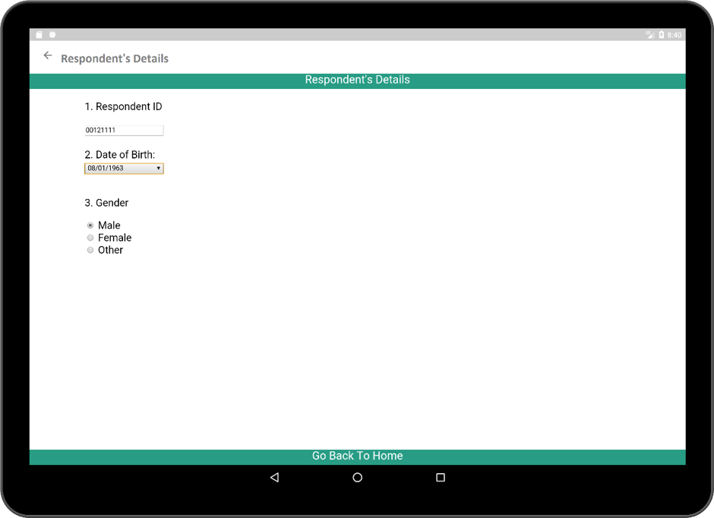

The Socio-Demographics activity
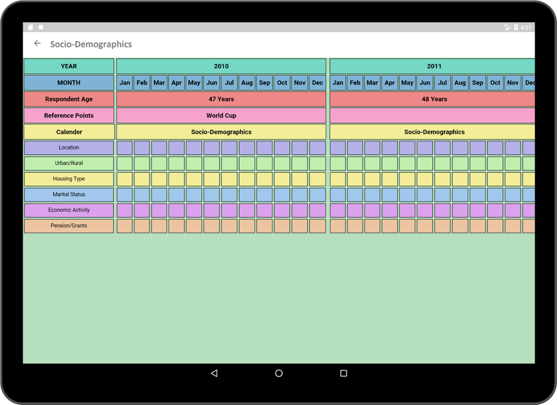

Pop-up window for Location (left) and Economic Activity (right)
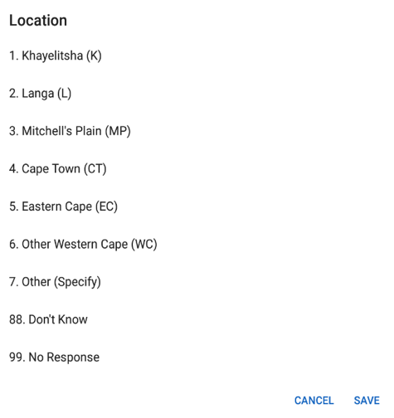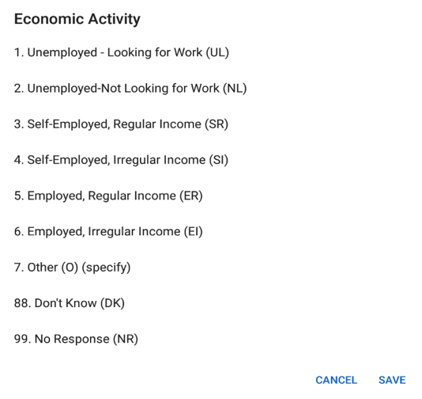

Sample of HIV Testing questions
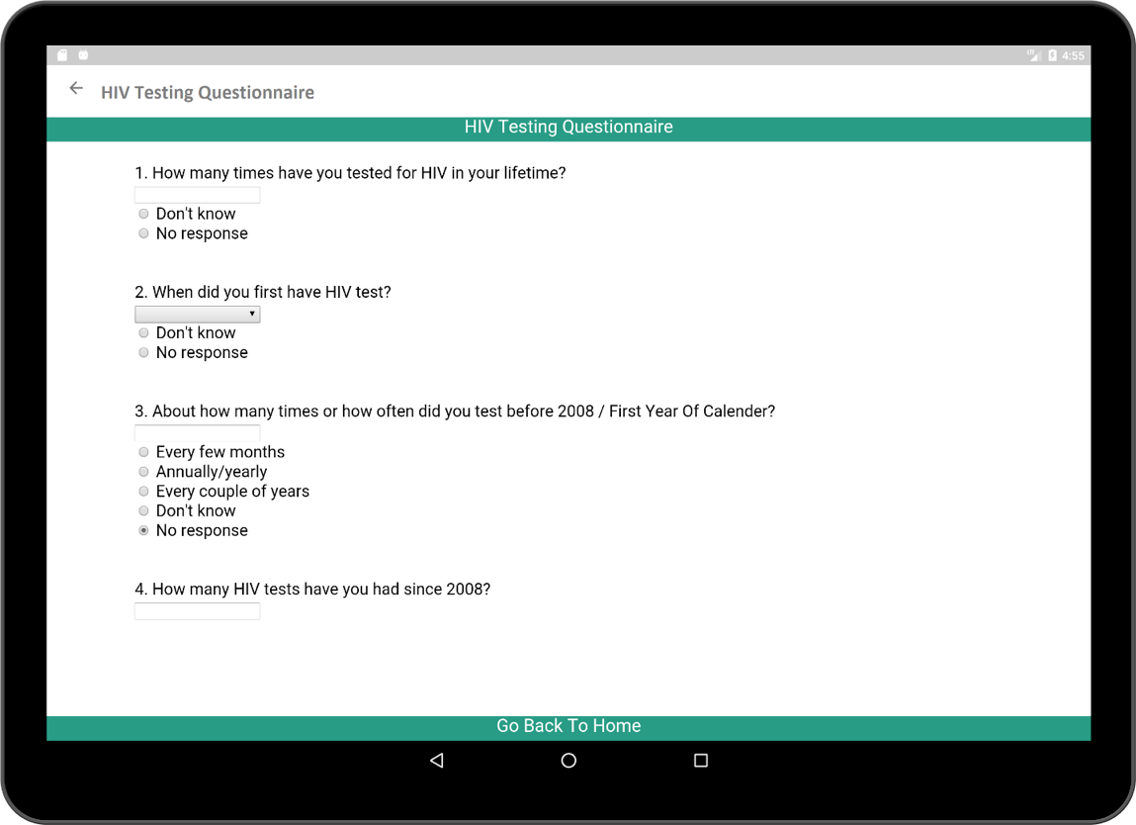

Health timelines
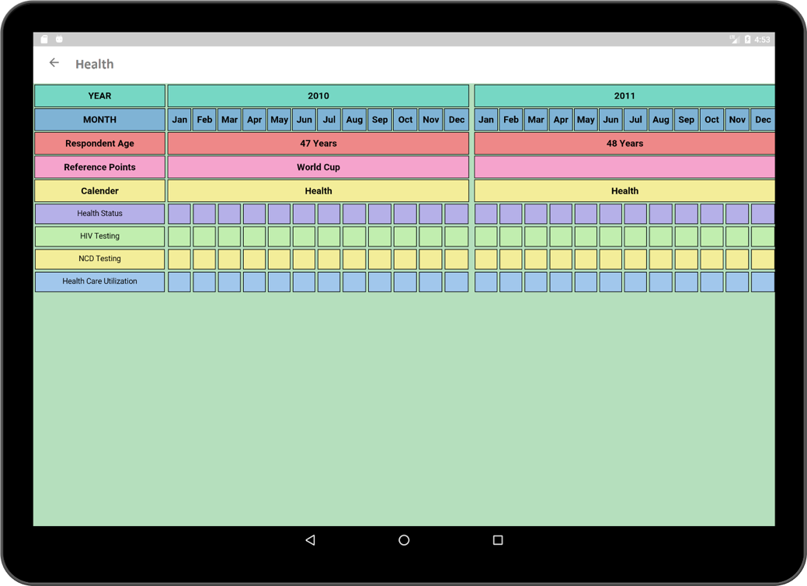

Pop-Up Questions for HIV Tests
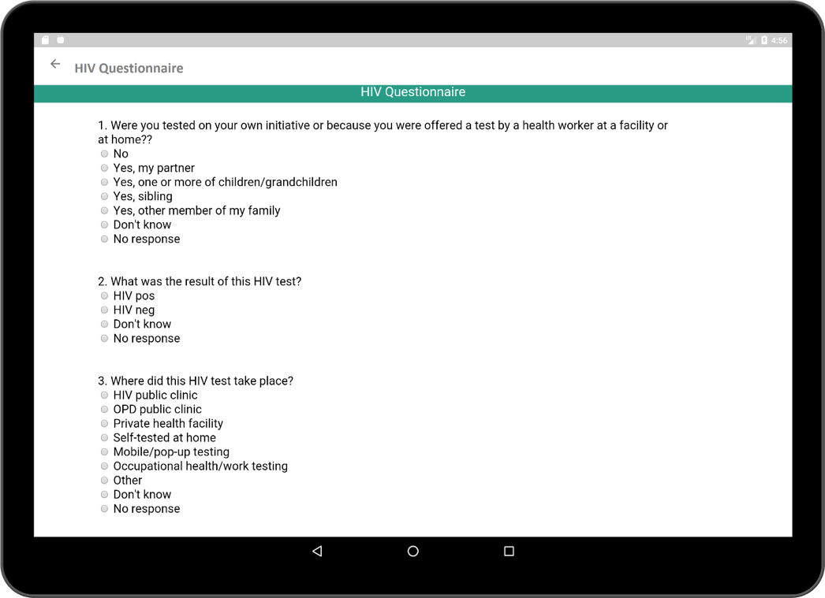

Relationship: calendar view
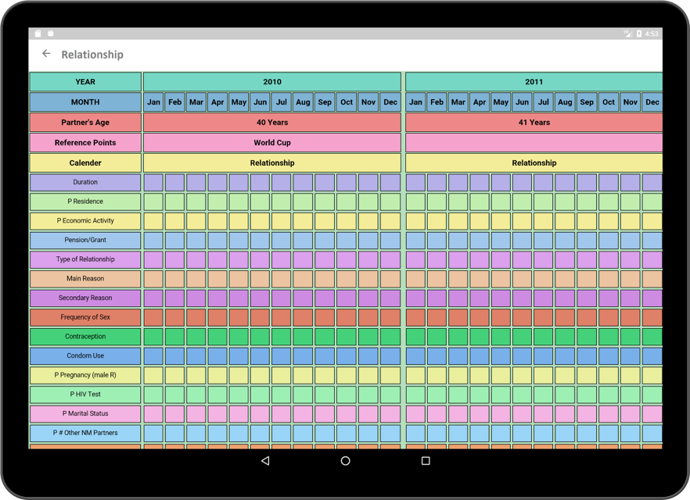

Dual-Window for comparion across sets of timelines
